# PROGRAM NO :2

**AIM:** Write a program that demonstrates Activity Lifecycle.

# PROGRAM CODE:

|  |  |
| --- | --- |
| Mainactivity.java | package com.example.activitylifecycle;  import androidx.appcompat.app.AppCompatActivity; import android.os.Bundle;  import android.util.Log;  public class MainActivity extends AppCompatActivity  {  @Override  protected void onCreate(Bundle savedInstanceState) {  super.onCreate(savedInstanceState); setContentView(R.layout.activity_main);  Log.d("Activity lifecycle","onCreate(): called");  }  @Override  protected void onStart()  {  super.onStart(); Log.d("Activity Lifcecyle",  "onStart: called");  }  @Override  protected void onResume()  {  super.onResume(); Log.d("Activity  Lifecycle","onResume: called");  }  @Override  protected void onPause()  {  super.onPause();  Log.d("Activity Lifecycle","onPause:  called");  }  @Override  protected void onStop()  {  super.onStop();  Log.d("Activity Lifecycle","onStop:  called"); |

**OUTPUT:**

}

@Override

protected void onDestroy()

{

super.onDestroy(); Log.d("Activity

Lifecycle","onDestroy: called");

}

@Override

protected void onRestart()

{

super.onRestart(); Log.d("Activity

Lifecycle","onRestart: called");

}

}

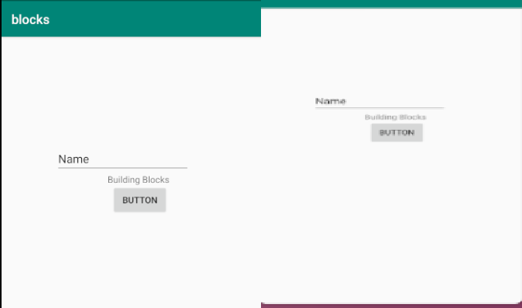

RESULT

Program Has Been Succesfully Executed And Output Is Obtained.